Greco-Roman culture

11 Ways Ancient Greece Influenced Modern Society By Anonemuss Mar 10, 2025 7:15 PM EDT Greek Influence on Western Culture The culture of Greece evolved over thousands of years, and is widely considered to be the cradle of modern Western culture. Political systems and procedures like democracy, trial by jury and lawful equality originated there. Ancient Grecian thinkers laid the intellectual foundations of many fields of study. Whether it be astrology, mathematics, biology, engineering, medicine or linguistics, much of the information we take for granted today was discovered or popularized by the ancient Greeks. The Greeks also established many of the standards by which we identify beauty and creative value in art, including literature, music, architecture, design and the performing arts. In short, if you live in the West, you are more like an ancient Grecian than you may realize. This article highlights some of Greece’s most significant contributions to Western culture. 11 Greek Contributions to Western Civilization Democracy The Alphabet The Library The Olympics Science and Mathematics Architecture Mythology The Lighthouse Standardized Medicine Trial by Jury The Theater 1. Democracy According to Merriam-Webster, a democracy is “a form of government in which supreme power is vested in the people and exercised by them directly or indirectly through a system of representation, usually involving periodic free elections.” The ancient Greeks created the world’s first democracy. Athens started out with a monarchy, advanced to an oligarchy, and then finally reached a democracy. The democratic government consisted of 6,000 assembly members, all of whom were adult male citizens, and they voted on issues throughout Athens. In order for a law to pass, the number of votes needed to be a majority. But, in order to banish or exile someone, all 6,000 votes were needed. Today in the United States, we use a democratic system. But instead of a direct democracy, we have a representative democracy in which citizens democratically vote on who should make political decisions. This is different than ancient Greece’s direct democracy, where citizens voted on the decision itself, rather than choosing people to make the decision. 2. The Alphabet Derived from the earlier Phoenician alphabet, the Greek alphabet was the first Western alphabet, featuring distinct letters for vowels and consonants. It was developed after the Dark Ages and consisted of 24 letters ordered from alpha to omega. The word “alphabet” actually originates from the first two letters of the Greek alphabet: alpha and beta. Some letters of our modern alphabet originated in ancient Greece, including the letters A, B, E, and O. The Greek alphabet originally had a single form for each letter, but eventually created upper and lower case letters. 3. The Library The first library in the world, the Library of Alexandria, was actually built in Egypt. However, at the time, Egypt was under Greek control after submitting to Alexander the Great. The Macedonians spread the Greek way of life to all of their conquered lands, including Egypt. After Alexander’s death, the Kingdom of Egypt came under the rule of Alexander’s general, Ptolemy, after a power struggle. Ptolemy ordered the construction of a library to contain over 700,000 scrolls of work. There was also a rule that all ships passing through the Alexandrian harbor had to declare if they had any works of science or philosophy. If they did, the work was copied and placed in the library, and the original was returned to the captain. Because of this accumulation of knowledge, many great discoveries took place in the library. For example, it was there that Eratosthenes calculated the circumference of the earth and drew up plans for steam power. Today we have libraries all over the world that collectively house billions of works of art and literature. But, the first library in the world was the Library of Alexandria. 4. The Olympics The Olympic Games lasted from the 8th century BCE to the 4th century BCE before dying out. They were so named because they started in the city of Olympia in ancient Greece. They were held every four years in honor of the king god, Zeus, and participants came from ancient Greek city-states and their colonies to participate and watch. Prizes for winning were fame and glory. Statues of winners were erected and sometimes winners’ faces were put on coins. Panhellenic Games Ancient Greece also staged other sports festivals: Pythian Games, held in honor of the sun god, Apollo Isthmian Games, held in honor of the sea god, Poseidon Nemean Games, also held in honor of Zeus What Are the Origins of the Modern Olympic Games? Today, we celebrate the Olympic Games in both summer and winter, continuing some of the old traditions, like leaf crowns, the lighting of the flame, and the opening and closing ceremonies. The modern Olympic Games was the brainchild of Baron Pierre de Coubertin. Seeing an opportunity to bring the world together through sport, Coubertin founded the International Olympic Committee (IOC) on June 23, 1894. In tribute to ancient Greece, the first Olympics staged by the IOC was held in Athens during the summer of 1896. The 1896 Games brought together 14 nations and 241 athletes who competed in 43 events. What Is the Meaning of the Olympic Rings? The Olympic Rings were designed by Baron Pierre de Coubertin in 1912. The black, yellow, green and red rings against a white background were intended to represent the five participating continents: Africa, Asia, Oceania (Australia/Polynesia), America, and Europe. They were also the colors of the flags of the first group of participating countries. Upon releasing the design, Coubertin said: "The six colors [including the flag's white background] combined in this way reproduce the colors of every country without exception. The blue and yellow of Sweden, the blue and white of Greece, the tricolor flags of France, England, the United States, Germany, Belgium, Italy and Hungary, and the yellow and red of Spain are included, as are the innovative flags of Brazil and Australia, and those of ancient Japan and modern China. This, truly, is an international emblem." What Does the Olympic Flame Symbolize? Another common symbol of the Olympic Games is the flame. The idea came from ancient Greece, where a sacred fire was kept burning throughout the Olympics in tribute to Hestia, Greek goddess of the hearth. The tradition of lighting an Olympic flame was reintroduced during the 1928 Summer Olympics in Amsterdam. The torch relay was then added at the Berlin Games in 1936. 5. Science and Mathematics Many famous mathematicians and scientists were born in ancient Greece. Archimedes Archimedes is generally considered the greatest mathematician of all time. He anticipated modern calculus, geometrical theorems, and learned to calculate the area of geometric shapes, including the circle and sphere. Some of Archimedes other achievements include coming up with an accurate approximation of pi and designing effective levers and pulleys. One of his famous quotes was, “Give me a lever long enough and I will move the Earth!” Eratosthenes Eratosthenes was a mathematician, geographer, and astronomer and the first person to calculate the circumference of the Earth. He did this by comparing the altitudes of the midday sun at two different locations. He also calculated the tilt of the Earth’s axis, and eventually became the chief librarian of the Library of Alexandria. Aristarchus of Samos Aristarchus was the first to create a heliocentric model of the universe, with the Earth revolving around the sun once a year and rotating about its axis once a day. He also placed the planets of the solar system around the sun in the right order, and thought stars were similar to other celestial bodies like the sun. In the 16th century, Nicolaus Copernicus advocated his version of the heliocentric theory and there’s some dispute as to whether he was aware of Aristarchus work 18 centuries earlier. Hipparchus Hipparchus is generally known as the greatest astronomer of antiquity. He developed the first models depicting the movement of the sun and the moon, and may have been the first to predict solar eclipses. 6. Architecture The most famous example of Greek architecture is the Parthenon, a former temple located on the Acropolis. Its most distinctive feature are its many columns: seventeen on the sides and eight columns at either end, inside of which is a second row of six columns. Today, columns are used in many public buildings, like churches and libraries. For example, there are columns throughout Washington D.C., including the U.S. Capitol, the Supreme Court Building, the Russell Senate Office Building and the Cannon House Office Building. What Inspired Greek Architecture? Ancient Greek architectural structures were designed with the gods in mind. Sometimes, this is obvious. The Temples of Zeus, Hera, and Artemis are named after their patron deities. However, both the Parthenon and Erechtheion were dedicated to the goddess Athena. Greek design is characterized by precision, adornment, largesse, and synergy. All elements are designed to complement and relate to one another. Because Greek structures were inspired by the gods, it’s ironic that most contemporary buildings mimicking Greek style are secular, government centers. Three Orders of Classical Greek Architecture Architectural orders are defined by column design and entablature (the ornate molding at the top of each column). In fact, through these columns you can track the aesthetic development of Greek architecture. The three classical orders are Doric, Ionic, and Corinthian, each described below. Doric Originating on the mainland and western Greece, the Doric order is the simplest of the orders and is characterized by short, faceted columns with unembellished, round capitals (tops) and no base. The columns are the smallest of the orders and are channelled with 20 flutes. Ionic Originating in eastern Greece, the ionic order is characterized by long and slender fluted pillars with a large base and two opposing scrolls built into the capital. The scrolls are often engraved with an egg-and-dart motif, and the pillars feature four more flutes than Doric columns. Corinthian Considered the most elegant of the three orders, the Corinthian order features ornate fluted columns and capitals studded with two rows of acanthus leaves and four scrolls. The shaft of the Corinthian column has 24 flutes. The oldest known building designed in the Corinthian order is the Choragic Monument of Lysicrates in Athens, which was constructed from 335 to 334 BCE. 7. Mythology Some of the most famous myths of ancient Greece are the tales of Perseus, Theseus, and of course, Hercules. The Greeks often used these myths to explain things that science couldn’t prove, but today we mostly enjoy them for entertainment purposes. Greek mythology has pervaded nearly every form of popular culture. Many Greek myths have been adapted into modern novels, movies, TV shows, video games and even brands, sometimes without people even realizing it. Some well-known instances of Greek mythology in pop culture are: Disney’s Hercules The bestselling novel Percy Jackson and the Olympians The God of War video game franchise The TV show Battlestar Galactica Mary Shelley’s Gothic novel Frankenstein; or, The Modern Prometheus The athletic brand Nike (Nike was the Greek goddess of victory) The use of the term “Achilles’ heel” to describe a weak spot 8. The Lighthouse Like the first library, the first lighthouse in the world was located in the Greek-controlled Egyptian city of Alexandria. The structure was called the Lighthouse of Alexandria, or the Pharos of Alexandria. Taller than the Statue of Liberty, it was the second tallest structure of its day (only the Great Pyramid of Giza was taller). The lighthouse had three layers: A square-shaped base An octagonal mid section A round beacon on top The lighthouse could be seen by fire at night, and by the smoke of the fire by day. Sadly, the lighthouse was destroyed by earthquakes, but it set the model for all future lighthouses. 9. Standardized Medicine While medicine was practiced in Babylon, China, India, and Egypt, the Greeks were the first to create a standardized system of medicine, including diagnosis, prognosis, and medical ethics. The manner in which the medical practice is carried out today, in terms of diagnosis and sometimes of treatment, is very similar to that of the ancient Greeks. These ancient advancements in medicine were largely instituted by Hippocrates, who is often called the “father of medicine.” The Innovations of Hippocrates Aside from theories and ethics about how physicians should practice medicine, Hippocrates made direct contributions to the application of medicine. In a time when people believed that illnesses were punishments from the gods, he taught that all ailments had natural causes. Some of Hippocrates’ contributions include: Hippocratic Oath The Hippocratic Oath is a historical sworn statement by physicians in which they swear by the names of a number of healing gods to uphold specific ethical standards. These include principles such as medical confidentiality and non-maleficence (aka “do no harm”). Below is a excerpt from the full text of the Hippocratic Oath, which remains a rite of passage for some medical graduates. "I will use treatment to help the sick according to my ability and judgment, but never with a view to injury and wrong-doing. Neither will I administer a poison to anybody when asked to do so, nor will I suggest such a course. Similarly I will not give to a woman a pessary to cause abortion. But I will keep pure and holy both my life and my art. I will not use the knife, not even, verily, on sufferers from stone, but I will give place to such as are craftsmen therein." Diagnosis of Medical Conditions Hippocrates was the first medical practitioner to categorize illnesses as acute, chronic, endemic, and epidemic. He was also the first to introduce terms such as exacerbation, relapse, resolution, crisis, paroxysm, peak, and convalescence. Treatment When it came to broken bones, hemorrhoids, and other ailments, Hippocrates and his followers came up with advanced treatments that reduced pain and sped up recovery. He employed the use of cauterization and excision to treat hemorrhoids, and in some cases these methods are still used today. 10. Trial by Jury The citizens of ancient Athens were the first to employ trial by jury. Jurors were required to be male citizens of Athens, and a mechanism known as dikastaí ensured that no person could select jurors for their own trial. Normal cases summoned a jury of up to 500 jurors. For more serious cases, like those involving death, up to 1,501 jurors could be summoned. With so many jurors, the unanimity rule employed in today’s courts would not work, so the verdicts of ancient Athens were reached by majority. Jurors were compensated one day’s wages for sitting in court. How Does Trial by Jury Work? A trial by jury in the United States today works much the same as it did in the time of ancient Greece. After hearing the final arguments of the defendant or their legal representative, the jury—which consists of 12 citizens—leaves the courtroom and enters deliberation. In nearly all cases, the jury must come to a unanimous decision of either guilty or not guilty. If the jurors cannot agree on a verdict in a reasonable amount of time the result is called a hung jury, which leads to a mistrial. Thus, the case must be tried again before a new jury. 11. The Theater If you’ve ever gone to a concert, play, or movie, you’ve benefited from one of the ancient Greeks’ most obvious contributions to the modern world: the theater. The word “theater” is derived from the Greek word “theatron,” meaning the seating section of outdoor arenas where people watched plays. The first western theater originated in Athens, and was, like many other ancient Greek theaters, a semi-circular structure cut into a hillside capable of seating 10,000 to 20,000 people. Theater as Physical Space The standard Greek theater consisted of three sections: a dancing floor, a dressing room, and a scene-building area. The acoustics of the theater were one of its most important features, allowing the words of the exclusively male actors to be heard by everyone within earshot. The ancient Greeks loved plays, and each town had its own performing company which competed against companies of neighboring towns. Theater as Art Beside creating the physical structure of a theater, the ancient Greeks also created “theater,” the art form which employs actors, stage setting, and sometimes music to create a story—usually a comedy, tragedy, or satyr play—in the 6th century BCE. Aeschylus, Sophocles, and Euripides The first playwrights (as we use the word today) originated in Greece with writers like Aeschylus, Sophocles, and Euripides. These men deserve credit for creating theater as we know it, and have had a major impact on how storytellers throughout the ages have chosen to deliver their narratives.

Traces of Ancient Rome in the Modern World by Gokhale, A. P. (2021)
The ideas and culture of ancient Rome influence the art, architecture, science, technology, literature, language, and law of today.

Grades
3 - 12

Subjects
Anthropology, Archaeology, Social Studies, World History
Image

Pont du Gard Aqueduct
This is the Roman aqueduct of Pont du Gard, which crosses the Gard River, located in France. It is a UNESCO World Heritage Site.
Robert Harding Picture Library
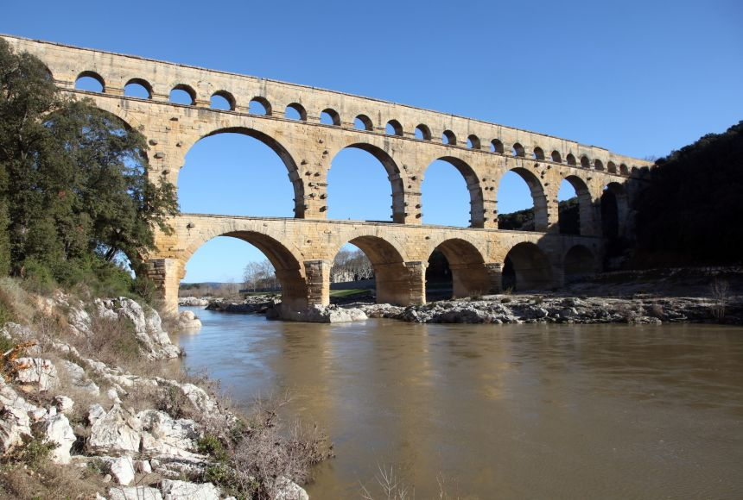
Leveled by
Selected text level
ArticleVocabulary
Ancient Rome had a large influence on the modern world. Though it has been thousands of years since the Roman Empire flourished, we can still see evidence of it in our art, architecture, technology, literature, language, and law. From bridges and stadiums to books and the words we hear every day, the ancient Romans have left their mark on our world.
Art and Architecture
Ancient Romans have had a tremendous impact on art and architecture. We can find traces of Roman influence in forms and structures throughout the development of Western culture.
Although the Romans were heavily influenced by ancient Greece, they were able to make improvements to certain borrowed Greek designs and inventions. For example, they continued the use of columns, but the form became more decorative and less structural in Roman buildings. Ancient Romans created curved roofs and large-scale arches, which were able to support more weight than the post-and-beam construction the Greeks used. These arches served as the foundation for the massive bridges and aqueducts the Romans created. The game-loving ancients also built large amphitheaters, including the Colosseum. The sports stadiums we see today, with their oval shapes and tiered seating, derive from the basic idea the Romans developed.
The arches of the Colosseum are made out of cement, a remarkably strong building material the Romans made with what they had at hand: volcanic ash and volcanic rock. Modern scientists believe that the use of this ash is the reason that structures like the Colosseum still stand today. Roman underwater structures proved to be even sturdier. Seawater reacting with the volcanic ash created crystals that filled in the cracks in the concrete. To make a concrete this durable, modern builders must reinforce it with steel. So today, scientists study Roman concrete, hoping to match the success of the ancient master builders.
Sculptural art of the period has proven to be fairly durable, too. Romans made their statues out of marble, fashioning monuments to great human achievements and achievers. You can still see thousands of Roman artifacts today in museums all over the world.
Technology and Science
Ancient Romans pioneered advances in many areas of science and technology, establishing tools and methods that have ultimately shaped the way the world does certain things.
The Romans were extremely adept engineers. They understood the laws of physics well enough to develop aqueducts and better ways to aid water flow. They harnessed water as energy for powering mines and mills. They also built an expansive road network, a great achievement at the time. Their roads were built by laying gravel and then paving with rock slabs. The Roman road system was so large, it was said that “all roads lead to Rome.”
Along with large-scale engineering projects, the Romans also developed tools and methods for use in agriculture. The Romans became successful farmers due to their knowledge of climate, soil, and other planting-related subjects. They developed or refined ways to effectively plant crops and to irrigate and drain fields. Their techniques are still used by modern farmers, such as crop rotation, pruning, grafting, seed selection, and manuring. The Romans also used mills to process their grains from farming, which improved their efficiency and employed many people.
Literature and Language
Much of the literature of the world has been greatly influenced by the literature of the ancient Romans. During what is considered the “Golden Age of Roman Poetry,” poets such as Virgil, Horace, and Ovid produced works that have had an everlasting impact. Ovid’s Metamorphoses, for example, inspired authors such as Chaucer, Milton, Dante, and Shakespeare. Shakespeare, in particular, was fascinated by the ancient Romans, who served as the inspiration for some of his plays, including Julius Caesar and Antony and Cleopatra.
While Roman literature had a deep impact on the rest of the world, it is important to note the impact that the Roman language has had on the Western world. Ancient Romans spoke Latin, which spread throughout the world with the increase of Roman political power. Latin became the basis for a group of languages referred to as the “Romance languages.” These include French, Spanish, Italian, Portuguese, Romanian, and Catalan. Many Latin root words are also the foundation for many English words. The English alphabet is based on the Latin alphabet. Along with that, a lot of Latin is still used in the present-day justice system.
Law
The use of Latin words is not the only way the ancient Romans have influenced the Western justice system. Although the Roman justice system was extremely harsh in its punishments, it did serve as a rough outline of how court proceedings happen today. For example, there was a preliminary hearing, much like there is today, where the magistrate decided whether or not there was actually a case. If there were grounds for a case, a prominent Roman citizen would try the case, and witnesses and evidence would be presented. Roman laws and their court system have served as the foundation for many countries’ justice systems, such as the United States and much of Europe.
The ancient Romans helped lay the groundwork for many aspects of the modern world. It is no surprise that a once-booming empire was able to impact the world in so many ways and leave a lasting legacy behind.

Definition

by Donald L. Wasson
published on 27 September 2017
Available in other languages: French, Spanish, Turkish
Subscribe to topic Subscribe to author Print Article PDF
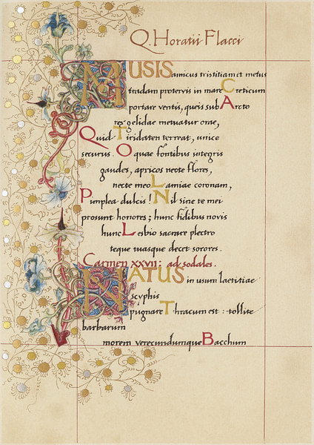
Odes of Horace
Digital Collections at the University of Maryland (CC BY-NC-ND)

The Roman Empire and its predecessor the Roman Republic produced an abundance of celebrated literature; poetry, comedies, dramas, histories, and philosophical tracts; the Romans avoided tragedies. Much of it survives to this day. However, Roman literature cannot stand alone. They owe a debt to their neighbor, the Greeks (more specifically Athens). Most educated Romans were well aware of their own literary inferiority, and because of this Roman writers could easily copy Greek classical themes, even going so far as to translate many of the notable Greek works into Latin. However, to many Romans, this exercise would have been needless, for a number of highly educated citizens could speak and read both Greek and Latin. Many young, upper-class Romans even continued their education in Athens. Although the link to Greek Hellenism would remain for years to come, the Romans would soon develop a rich literature of their own.

Greek influence
Roman literature owes a debt to the Greeks, more specifically Athens.
This indebtedness to Greece was even recognized by the writers themselves. Horace, one of the poets of the Golden Age of Roman literature wrote that Greece introduced the arts "into a backward Latium." Historian Nigel Rodgers in his Roman Empire wrote that Greek authors originated many philosophical and political concepts that influenced such Romans as Cicero, Seneca, Boethius, Catullus, and Virgil - "a Greek and Roman synthesis" (258). He added that Rome could not and did not deny that Greece was more refined and superior in both intellectual and cultural pursuits from technology and philosophy to poetry and sculpture. In reality, Rome could hardly deny a closeness to Greece since Greek cities had existed on both the lower peninsula and Sicily for decades.

Comic playwrights
According to Rodgers, there was little in the way of Roman literature before the Punic Wars against Carthage (264 – 146 BCE). It was during this time that Rome became involved in the Macedonian Wars, eventually absorbing the Greek city-states. Roman literature began near the end of the 3rd century BCE with the emergence of such comic playwrights as Plautus, Terence, and Ennius. Quite often their plays would be performed during one of the city's many festivals where the audience was mostly male.
The first of the three was Plautus (254 – 184 BCE). Of his more than 130 plays, only 20 complete works survived. According to ancient sources, he was born in Umbria and began his career as a stage carpenter. He did not begin to write anything until middle age, adapting Greek comedies into Latin. He used the usual jokes, puns, and songs (duets and arias) which quenched the Roman desire for slapstick. Although he did not write in Greek, all of his characters had Greek names and resided in Greek cities. Two of his more notable works are Aulularia (The Pot of Gold) and Captivi (The Prisoners).
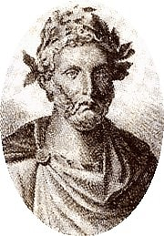
Plautus
Unknown Artist (Public Domain)

Publius Terentius Afer, better known as Terence (195 – 159 BCE), and Ennius (239 – 169 BCE) were Plautus' contemporaries. Terence arrived in Rome as a slave from North Africa, eventually gaining both his freedom and an education. Many of his plays, such as the comedy Eunuchus (The Eunuch), did not appeal to many of the unsophisticated Romans; he was criticized by his contemporaries for "cannibalizing" Greek plays.
Ennius, however, was more highly touted than either Plautius or Terence and is considered to be the "father of Latin poetry." Born in Calabria in southern Italy (Magna Graecia), he served in the Roman army in Sardinia, arriving in Rome with fellow writer Cato the Elder around 204 BCE, eventually obtaining the much-desired Roman citizenship. Even though he claimed to be the reincarnation of Homer, only fragments of his works have survived. Rodgers notes that he demonstrated how Latin poetry had achieved greatness while still emulating Greek forms. His Annals was a history of Rome from the mythical Trojan hero Aeneas through his own day. Unfortunately, he died in poverty.

Golden Age of Roman Poetry
As foretold by Ennius, Latin literature would soon truly come into its own. The Golden Age of Roman poetry (c. 70 BCE – 14 CE) produced such memorable writers as Virgil, Horace, Catullus, Propertius, Tibullus, and Ovid. According to Rodgers, Virgil, Horace, and the exiled Ovid created a classical style of writing comparable to many of the great Greek authors.
One of these distinguished poets was Publius Vergilius Maro or Virgil (70 – 19 BCE). Unlike many of the poets who followed him, Virgil provided his audience with a more romanticized picture of Rome. Hailing from Cisalpine Gaul and a family of modest farmers, many of Virgil's themes demonstrate his love of the rural life. His Eclogues, written around 37 BCE, spoke of the loves and lives of shepherds, while his Georgics, written around 29 BCE, praised Roman country life: plowing, growing trees, tending cattle, and even keeping bees. However, his most memorable work is the Aeneid, an epic telling of the journeys of Aeneas after the fall of Troy through the founding of Rome by Romulus and Remus to the age of Augustus. As Aeneas was the ideal model for the Roman way of life, Augustus believed the poem demonstrated a fulfillment of Rome's destiny.
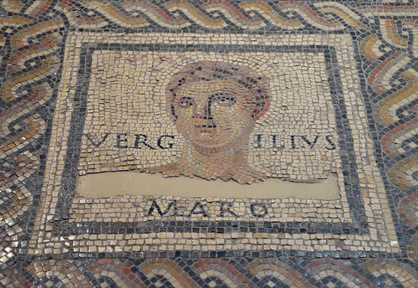
Portrait of Virgil
Carole Raddato (CC BY-NC-SA)

Quintus Horatius Flaccus, more commonly known as Horace (65 BCE – 8 BCE), was the son of a freedman. Although he fought on the wrong side at the Battle of Philippi (against Augustus), he endeared himself to the emperor partially because of his poetry but also due to his friendship with Virgil. In keeping with his Epicurean philosophy, Horace's poems demonstrated a joy for life and a love of nature. Among his many works are Satires, which was a criticism of the vice that was rampant in Rome, Epodes, inspired by the Greek author Archilochus, and Odes, a celebration of life in Rome during the age of Augustus. In all of his works, Horace always demonstrated a deep respect and admiration of the Greeks and believed Rome had to acknowledge the Greek superiority in all intellectual and cultural fields.
This new age under the reign of Augustus also produced many young poets who reacted differently to the changes in Roman politics and society. The leader of these emerging poets, Gaius Valerius Catullus (84 BCE – 54 BCE) is considered one of the greatest of all Roman lyric poets. Avoiding any personal involvement in politics, he looked to his neighbors to the east, such Greek authors as Sappho and Callimachus, for inspiration. According to historian Rodgers, his poetry mingled both passion and urbanity with an awareness of life's impermanence and he "raised colloquial Latin to new heights" (386). Similarly, historian Norman Cantor in his Antiquity said that Catullus recognized the mortality of man and exposed a different side of Roman life. His poems revealed the existence of pessimism, individualism, and deep feelings of self-indulgence within Roman society:
Furius, you who have neither a slave, nor a money-box, nor a bug, nor a spider, nor a fire, but who have a father and a stepmother too, whose teeth can chew even a flintstone, you lead a merry life with your father and that dry stick, your father's wife. (Catullus, Poem 23)
Other poets were inspired by long lost loves. The first of these lovelorn poets was Sextus Propertius (54 – 16 BCE), the son of an equestrian who unlike his fellow poets received legal training but rejected any career in politics. His most famous book of poems was Elegies. A friend of both Ovid and Virgil, he even received a home from the patron of arts Maecenas on the Esquiline Hill; however, unlike some of his contemporaries, he refused to write an epic about emperor Augustus. Like Propertius, Albius Tibullus (50 – 19 BCE), another son of an equestrian family, wrote about a lost love, Delia, and, like Virgil, he idealized the country life.
Probably the most famous or infamous poet of the era is Publius Ovidius Naro or Ovid (42 BCE – 18 CE). After Ovid, Roman poetry would take a brief hiatus. Rodgers wrote that with Ovid Latin poetry had finally attained an "elegance and lyricism" to rival that of any Greek. To Ovid love was the only "game worth playing." His Amores, published in 22 BCE, told in a very lighthearted style about the misadventures of a young man and his love for an unobtainable young girl. His Heroides was a series of 15 letters supposedly written by Greek and Roman mythological female figures such as Penelope and Dido to their lovers who had either mistreated or abandoned them. His Ars Amatoria mirrored Horace's Ars Poetica. However, his most famous work is the 15 books of mythology Metamorphoses, an epic poem that spoke not only of humanity's interaction with the gods but also of heroes and heroines. Unfortunately, Augustus did not look upon his poetry with admiration and exiled him. Although not appreciated during his lifetime, his works of poetry have influenced many of the great authors throughout history including Chaucer, Milton, Dante, Shakespeare, and Goethe.

Silver Age of Roman Poetry
Two famous Roman poets linked to what has been called the Silver Age of Roman poetry are Marcus Annaeus Lucanus, better known as Lucan (39 – 65 CE), and Publius Papinius Statius (45 – 96 CE). Lucan, born in Spain, was the nephew of Seneca, the advisor of Emperor Nero. He even studied Stoic philosophy in Athens; however, his suspected involvement in the Piso conspiracy would cost him his life. Pharsalia, his most famous work, dealt with the Roman civil war of the 1st century BCE. His lesser known contemporary Statius wrote the twelve books of Thebaid concerning Oedipus's curse on Thebes.

Roman Prose
While there was an abundance of poets in Rome, there were also many outstanding writers of prose. The city was alive with orators who took to the stage in the Roman Forum to voice their views to the masses. It was a platform as well for lawyers who wished to plead for their clients. One of the more memorable was Marcus Tullius Cicero (106 – 43 BCE), not only a brilliant statesman and author but also an orator who, besides his 911 letters, wrote on subjects ranging from art to education. In a series of caustic letters, he spoke out against the corrupt ex-governor of Sicily Verres forcing him into retirement, though the ex-governor would later be set free by Caesar. He wrote political essays such as De re publica (On the State) and De legibus (On the Laws) as well as five books in Latin on ancient philosophy – De finibus bonorum et malorum. His Epistulae ad familiares (Letters to family and friends) act as vivid historical and cultural documents of the period and give an insight into the inner workings of late Republic. Unfortunately, he had spoken out against Julius Caesar, something that angered the dictator's heir Octavian (Augustus). Having been exiled once, Cicero could not save himself and was executed before he could escape Rome.
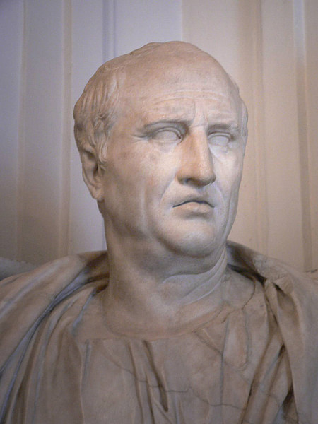
Cicero
Mary Harrsch (Photographed at the Capitoline Museum) (CC BY-NC-SA)

Lucius Annaeus Seneca (4 BCE – 65 CE) was a student of Stoic philosophy and tutor to Emperor Nero. Not only an essayist, he wrote nine plays based on such Greek legends as Oedipus, Heracles, and Medea. He also authored 124 essays on subjects ranging from vegetarianism to the humane treatment of slaves. After being implicated in the Piso conspiracy, he was forced to commit suicide by Nero.
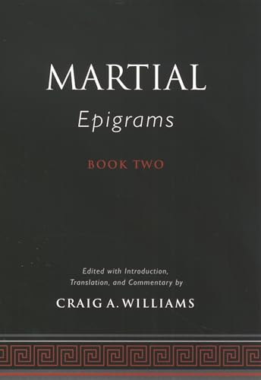
Book Recommendation
Martial's Epigrams Book Two
by Williams, Craig A. & Williams, Craig A.
published by Oxford University Press (2004)
$99.00

Pliny the Elder (23 – 79 CE) or Gaius Plinius Secundus was a Roman administrator who wrote on the Germanic wars and whose Natural History (Naturalis Historia) contained information on the known universe as well as tracts on animals, trees, and plants, all in 37 volumes. Volume III, for example, describes the geography of Italy and the topography of Rome:
If one were further to take into account the height of the buildings, a very fair estimate would be formed, that would bring us to admit that there has been no city in the whole world that could be compared to Rome in magnitude. (Pliny the Elder, Natural History, Book III, 67)
Observing the eruption of Mt. Vesuvius in 79 CE, Pliny the Elder died after inhaling fumes. His nephew Pliny the Younger (61 – c. 112 CE) had a successful career as both a senator and consul under Emperor Trajan. He is most noted for his long series of letters on a variety of topics to the emperor.
There were also a number of Roman novelists: Petronius, Apuleius, Martial, and Juvenal. Petronius or Gaius Petronius Arbiter (c. 27 – 66 CE) served as both a consul and governor of Bithynia. His most famous work and the only one to survive is the Satyricon, a work considered witty but amoral and hedonistic. Unfortunately, like several of his contemporaries, he was implicated in the Piso conspiracy during Nero's reign and was forced to commit suicide in 66 CE.
Lucius Apuleius (c. 124 – c. 170) from North Africa wrote a number of excellent works including the amoral The Golden Ass which is the only complete Roman novel to survive. One of the eleven separate books included in the novel spoke of the adventures of a young man named Lucius who is transformed into an ass. His other works include Apologia, Florida, and De Deo Socratis.
Marcus Valerius Martialis (c. 40 – c. 104 CE), better know as Martial, although originally from Spain, spent most of his life in Rome. A close friend of Emperor Domitian, he wrote epigrams on a variety of subjects, some of which might be called pornography:
Why don't I kiss you, Philaenis? You're bald. Why don't I kiss you, Philaenis? You're red-headed. Why don't I kiss you, Philaenis? You're one-eyed. Whoever kisses all that, Philaenis, sucks. (Martial, Epigram 2.33, in Williams, 128)
Decius Junius Juvenalis or Juvenal (c. 60 – c. 130 CE) is considered the greatest of the Roman satirists. Unfortunately, he ran afoul of Emperor Domitian who believed he had been portrayed negatively in the writer's Satires and may have been exiled to Egypt; his place of death is unknown.

Later Roman Literature
The spread of Christianity gave rise to a new type of literature from the 4th century CE, with clerics writing on Christian morality in sharp contrast to the amoral and often sexually explicit works of the previous centuries. One of the premier clerics of the 4th century was St. Ambrose (c. 340 – 397 CE). Ambrosius was the son of the praetorian prefect of Gaul and schooled in the classical Greek tradition. He served as bishop of both Rome and Milan as well as governor of Aemilia-Liguria despite often challenging the Emperor Theodosius. Among his writings are De officiis ministrorum, a discussion of morality and ecclesial discipline as well as De obitu Valentiniani and De obitu Theodocii which established the concept that a Christian emperor was a son of the church.
Remove Ads
Advertisement
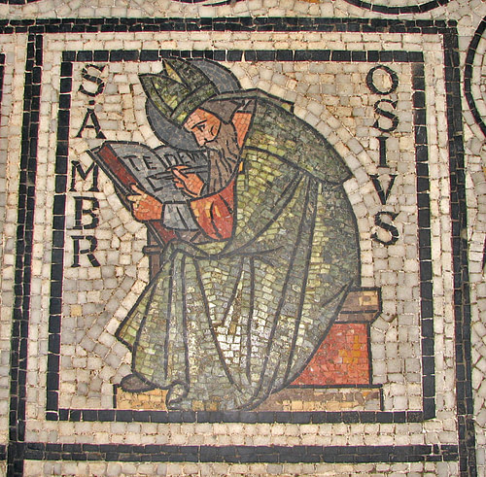
St. Ambrose
Fr Lawrence Lew, O.P. (CC BY-NC-SA)

Decimus Magnus Ausonius (310 – 395 CE) came from Bordeaux and served as the tutor for the future emperor Gratian; he was a noted grammarian and rhetorician. He was less concerned with Christian values and wrote on a variety of subjects. His more noted works are Praefatiunculae (Prefaces) and Eclogarum Liber (Eclogues), verses on astronomy and astrology. Lastly, one cannot forget the writings of St. Augustine (354-430 CE). He is most famous for his De civitate Dei (The City of God) which he wrote near the end of Western Roman Empire at the time of the invasion of 410 CE and his Confessions.
While Ambrosius, Augustine, and Ausonius represented the emergence of Christian writers, one pagan author also appeared on the scene, Claudius Claudianus (370 – 404 CE). Claudianus, a native of Alexandria, was the court poet under Emperor Honorius. He wrote panegyrics for Honorius and Stilicho, the Roman general. Influenced by earlier poets, both Roman and Greek, he is considered the last important poet of the classical tradition.

Historians
Besides the writers of poetry and prose, there were the historians: Sallust, Tacitus, Livy, and Suetonius. Unfortunately, much of early Roman history is based on myth, and some historians sadly accepted it as fact. However, real or not, it gave the Romans a sense of identity. The first historian of note was Gaius Sallustius Crispus or Sallust (c. 86 – 35 BCE), a former senator expelled for immorality. So inspired by the Greek historian Thucydides, he turned to writing history. An enemy of Cicero, he sided with dictator-for-life Julius Caesar who helped him fight charges of malpractice while governor of Africa. His most famous works include Bellum Catilinae, which dealt with the Catiline conspiracy, Bellum Iugurthinum, a book concerned with the Roman war against the Numidian king Jugurtha, and Histories, which remains only in fragments.
Livy (59 BCE – 17 CE) wrote a detailed history of Rome in 142 books, however, unfortunately only 35 survive. Although he accepted many myths as fact, his history demonstrated his belief in Rome's destiny.
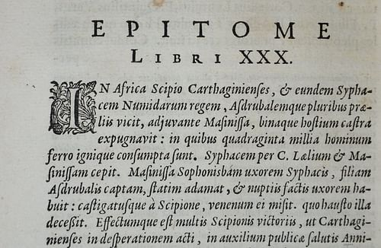
Livy's Roman History, 1664
Andy Brill (CC BY-NC-SA)

Cornelius Tacitus' (58 – 120 CE) works include De vita Iulii Agricolae, which spoke of his father-in-law's time as governor of Britain; Germania, dealing with the wars against the tribes of Germany; and the fragmented Annals and Histories.
Lastly, Gaius Suetonius Tranquillus (c. 69 – c. 130 CE) must be mentioned. His De viris illustribus included short biographies of Roman men of letters; poets, grammarians, orators, and philosophers. His De vita Caesarum (The Twelve Caesars) spoke of the Roman 'caesars' from Julius Caesar to Domitian. Using earlier histories as sources, his works are considered interesting but not totally reliable. They are concerned more with an emperor's personal habits than with his political accomplishments.
Remove Ads
Advertisement
Unfortunately, Rome did not produce many philosophers like Greece; however, there are two who should, at least, be mentioned. Marcus Aurelius was not only an excellent emperor but also a Stoic philosopher; his Meditations was written Greek. Finally, T. Lucretius Carus (99 – 55 BCE) wrote On the Nature of the Universe, an Epicurean doctrine that said the world was mechanistic, operating without divine intervention and true happiness existed from complete withdrawal from public life.

Legacy
From its infancy, Roman literature borrowed heavily from the Greeks. However, they were able to shake the shackles and create a vibrant literature of their own; poetry, prose, and history. The Roman authors influenced countless others in the decades and centuries that followed – Dante, Shakespeare, Milton, and many more. One cannot enter either a library or bookstore without seeing Roman poetry and prose on the bookshelves; Cicero, Tacitus, Suetonius, as well as Virgil and Horace. Western literature owes a debt of gratitude to the Romans for what they have given the world.

